
IAGenWeb

Notes:
Use this slide to set up the projector and leave it on while people gather.
You can do an introduction and when you are ready click to go to the next slide.

Say something like this:

The IAGenWeb is part of the USGenWeb Project, a group of volunteers working together to provide Internet websites for genealogical research in every county and every state of the United States. The Project is non-commercial and fully committed to free access for everyone.

Name each part of the project but don’t go into a lot of detail because the program will show parts of all these except for the World GenWeb.

If you want this picture to show YOUR county, send an e-mail to Barbara Hug at bhug@prairieinet.net and she will redo this graphic and send back to you if you give her more than a day’s notice.

Iowa is one of the best in the Country because when Iowa organized in 1977, our leadership set up some basic requirements.

These requirements:
- A search engine for the site.
- The addition of random data at least every 6 months. Such things as obituaries, births, deaths, etc. that are not complete.
- The addition of transcribed data at least every year. A complete set of data such as all obits from the 1910 Newspaper or all births in 1890 or all marriages in 1900.
- Timely communication with visitors to the site.

Not all people understands our name and have a hard time remembering it; you might want to use this explanation.

Just go through each one and then have them tell you the other two state. You could add others if you want.

Talk about your own experience or use your own words to tell the audience what you want. You don’t need go into a lot of detail here as you do that as you explain each component of the site – ie: when showing the GPP site, talk about the CC’s responsibility in approving all of the photos, etc.

This is just an introductory slide to let people know that these are the next three topics you’ll talk about.

These are the icons for the IAGenWeb Boards. At this point just name the icons and briefly tell what kinds of material goes with each icon.

Stress that this is the opportunity for genealogists to enter their own data about their family or about the community in which they live.

You’ll go through the HOW to submit later on.

Again, just mention each of the Special projects and the kinds of information you can get or add to it. Look on the special projects page on the IAGenWeb state site to get a brief description of each project.

You might want to mention that researchers can contribute to each of these projects.

These are the USGenWeb Special Projects

Archives: The USGenWeb Digital Library for Iowa was developed to provide free on line data for genealogical research.
The Archives was set up before a lot of the counties had on-line data. In Iowa most, not all, of the data is on the county sites. But in other states this is the place to look.
As with all other information found on GenWeb sites, these archives are dependent on volunteers to donate their time by transcribing public domain records or other non-copyrighted primary sources.

Tombstone Project: Again this was set up before many of the county sites put cemetery lists on their sites. Today most Iowa counties have extensive cemetery listings on the county sites. But you can always check here for information, especially in other states.

Other USGenWeb Projects:
I selected the Family Group Sheets, the kids site and penny postcards as a variety. You can pick out other that might be more appropriate for the people you are talking to.

Since we’ve been talking about the special projects, we need to emphasize that even though the special projects are helpful, the county site is the heart of the whole project.

You might also say that as of January 12, 2007 there were:
77 volunteers who serve as County Coordinators and
13 volunteers who serve as Assistant County Coordinators

Our volunteers spend any where from 1 to 10 hours per week (or more) on their county site.

Use this graphic if you want to discuss the IAGenWeb as a whole.

Point out the topics at the top of the page and the menu along the left side.

You might mention that the state does have an elected leadership team that changes each year.

Make a graphic own county page or use this one as an example.
To get a photo of your page:
- Open the page in your browser, close as many of the tool bars as possible – I usually leave in the address and menu tool bars.
- Locate the “Print Screen” key on your keyboard and press – usually top row next to the F12 and/or Scroll Lock.
- Open a graphics program like Paint Shop Pro and paste the image as a new image. Then crop or resize. (if you don’t have a graphics program that will accept a new image, write to Barbara Hug at bhug@prairieinet.net and she’ll do it for you and send back to you.

Talk in general about the county site and point out some of the features you are especially proud of.

You can make additional graphics of your site by using the above instructions.

Talk about ways that volunteers can assist. Change or add any point here that you want. Perhaps there is a special project you are working on that you want to advertise.

Use the following slides to show how to contribute.

Show the various parts to this screen. The fact that you can enter Queries, Obituaries, Biographies and Documents – news items, wills, etc.

You can point out that this site has 485 obituaries on site. Tell the group how many obituaries, queries, biographies and/or documents you have your county site.

Point out the box where you put in a Surname to search.

Also point out they can choose to select just the Surname or the Surname and or other words in the text part of the message. [In case you can’t find that option, look just above the Search for windows.

Point out the link to the Posting option. I have no idea what “Unsubscribe” means and the Search All Counties is been disconnected for the present.

Use this graphic to show people how easy it is to submit an obituary.

They can either type the obituary in the box or type it in word processor and then copy and paste into the box.

Suggest they leave a space between paragraphs so it the obit is easier to read.

Explain each of the other features that are highlighted.

Explain that the Biography, Document and Query boards work in the same manner.

The Gravestone Photo Project (GPP) is done in a different way from the other projects so it is shown here.

Iowa Gravestone Photo Project History
The "Gravestone Photo Project" or "GPP" was first undertaken as a single county gravestone photo archive. Originating as an IAGenWeb Special Project in January 2003, it has grown to include separate repositories in over a dozen states -- and is now believed to be the largest gravestone photo repository in the world.

On this graphic point out that the researcher can:
- select the county you wish to search OR the whole state
- search for a Surname, First Name or a Cemetery
- search for a name that starts with, sounds like or contains

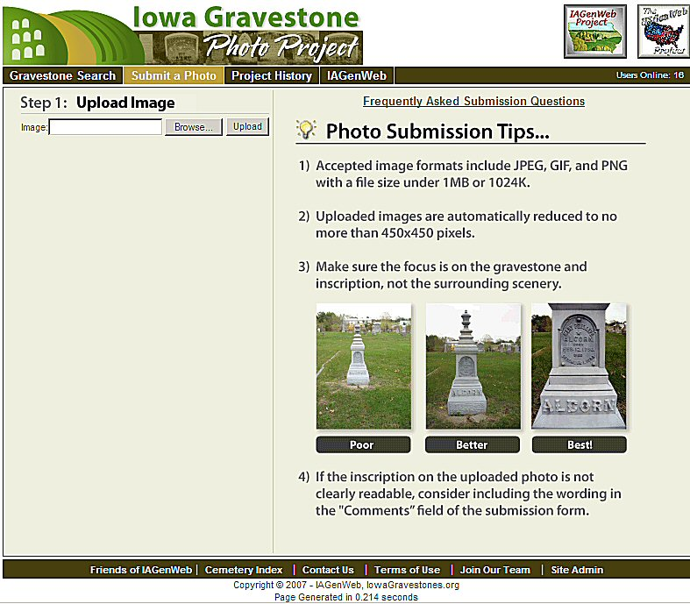

This is the first page in the Submit a Photo.

Talk about the photo submission tips.
Add to these tips:
- Clean of stone. Bird droppings aren’t a very nice way to remember your ancestors. Also brush off loose grass and pull away weeds and grass around the stone.
- If the engravings on the stone don’t show up very well, spray water on the stone as the water darkens the stone allowing the engravings to stand out just a little more.
  - DO use any chemicals on the stone to make engraving stand out as chemicals damage the stone.
  - NEVER use chalk, flour or other products to mark the stone to show the engraving.
  - Write down the engraving to add to the Comment Section of the photo submission form.
- Watch the reflections in the tombstone – your feet, etc. – The next graphic will show a neighborhood dog that just happened to be in the cemetery when the photo was taken.

This graphic shows the Submit page.

Go through each part of the submission

Encourage people to enter information in the Comments box.

Point out that this is a POOR photo to submit because the image of the dog walking around in the cemetery shows up in the tombstone. Peoples feet and bodies and shadows often show up on photos like this. SO be careful when taking the photo.

Us this graphic to show how to add a post-em note to an existing gravestone photo.

This is a new feature of the Gravestone Photo Project.

Location of the Join Our Team link on the state page.

These are the ways volunteers can contribute.

Talk about any or all of these as you have the time for and what seems to best fit the audience.

Point out that this page gives the names and links to all the Iowa counties.

The side menu gives links to a state-wide map, the names of the county coordinators by surname and by county the serve.

This is a graphic of the volunteer form to complete.

In some counties there is a distrust between the county genealogical society and the GenWeb project.

This distrust seems to be monetary: traditionally the local society has made money by selling books of vital records, obituaries, histories, etc. Obviously if the availability of online information cuts into their profits.

Many counties have found that the request for research and copying original documents has actually been more profitable than the sales the might have lost.

Suggest that local societies use different ways to add to their revenues than selling books: ie: Have a listing of probates on line with the local society providing the service of copying the probate record; putting flowers on ancestors graves – think outside the traditional box.

Use the Internet to the advantage of both groups.

Use this or another graphic to summarize your presentation and to say goodby.

